Software Requirements Specification

Version 1.2

February 7, 2020

Electric Blender

By: Ahmed Geneidi

Status : Draft

Submitted in partial fulfillment
Of the requirements of
Software Engineering

Document History

Version | Author | Date | Change description
1.1 | Ahmed Geneidi | 1/02/2020 | Adding the document statues and the document history table
1.2 | Ahmed Geneidi | 7/02/2020 | Editing the SRS document based on the feedback we got by doing the follows:  - Making the document history at the start before Table of Contents.  - Adding reference table at the end of the document.  - Covering the added requirement in version 1.2 in the CYRS .  - Updating the table of contents.  - Making the status of the document as draft.

Table of Contents

Document History i
Table of Contents ii
1.0. Introduction 1
1.1. Purpose 1
1.2. Scope of Project 1
1.3. Intended Use 2
1.4. Overview of Document 2
2.0. Overall Description 3
2.1 System Environment 3
2.2 Functional Requirements Specification 4
2.2 Functional Requirements Table 7

1.0. Introduction

1.1. Purpose
The purpose of this document is to present a detailed description of the Electric Blender System. It will explain the purpose and features of the system, the interfaces of the system, what the system will do, the constraints under which it must operate and how the system will react to external stimulants. This document is intended for the developers of the systems

1.2. Scope of Project
This software system will be an embedded software system that will control the Electric Blender. This system will be designed to allow the user of the blender to have the privilege to control the speed of the motor that drives the blender. The user interface to the motor speed will be through the external push button.
More specifically, this system is designed to allow accessibility to full speed motor control from speed one to speed two and three also he can choose to make the motor on or off. The software will facilitate the interface between the user and the blender so that with only pressing the bush button he will change the speed of the dc motor. The system could also measure the input voltage to the blender so that if any voltage drop occurs the system shall be off in order to provide protection over the blender to avoid any damage to the hardware with the software.

1.3. Intended Use
. This document is released to software architect’s developers and the testing team.

1.4. Overview of Document
The next chapter, the Overall Description section, of this document gives an overview of the functionality of the product. It describes the informal requirements and is used to establish a context for the technical requirements specification in the next chapter.
The third chapter, Requirements Specification section, of this document is written primarily for the developers and describes in technical terms the details of the functionality of the product.
Both sections of the document describe the same software product in its entirety.

2.0. Overall Description

2.1 System Environment
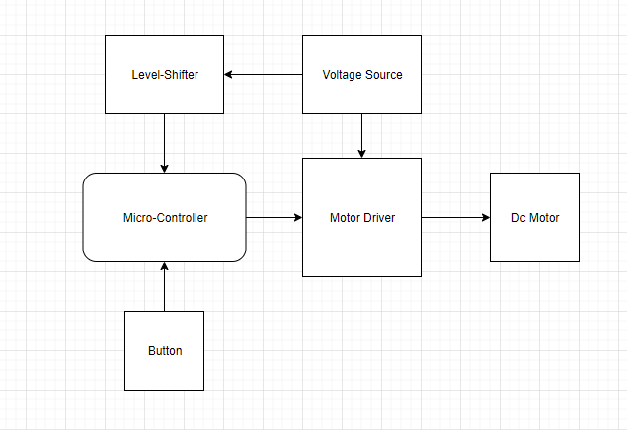
Figure 1 - System Environment

The Electric Blender System has a microcontroller that controls the dc motor which drives the electric blender, and also monitors the input voltage to the blender to avoid any voltage dropdown, so the inputs to the microcontroller are the push button and the level shifter output the input to the microcontroller, the use of the level shifter is to level down the +12V input to the dc motor to only +5V so it could be configured as an input to the microcontroller.

2.2 Functional Requirements Specification
[REQ_ PO2_EBL_Electric_Blender_SRS_001.1-1.0]
{This function shall read the status of the push button if the bush button is
Pressed or released it should return TRUE if it was pressed or FALSE if it was released.
} covers [ Req_ PO2_EBL_Electric_Blender_CYRS_002-1.0]

[REQ_ PO2_EBL_Electric_Blender_SRS_001.2-1.0]
{This function shall return the number of time the push button was pressed for example if it was pressed two times the function shall return two.
The maximum number of pressing times are four.
} covers [ Req_ PO2_EBL_Electric_Blender_CYRS_002-1.0]

[REQ_ PO2_EBL_Electric_Blender_SRS_001.3-1.0]
{This function shall set the duty cycle to configure the PWM to set the motor three speeds:
Speed 1 ➔ from 0% up to 30% of the duty cycle.
2 times ➔ from 30% up to 60% of the duty cycle
3 times ➔ from 60% up to 100% of the duty cycle
} covers [ Req_ PO2_EBL_Electric_Blender_CYRS_001-1.0]

[REQ_ PO2_EBL_Electric_Blender_SRS_001.4-1.0]
{This function shall set the duty cycle to configure the PWM depending on the number of times the button was pressed based on the following:
1 time ➔ Speed 1
2 times ➔ Speed 2
3 times ➔ Speed 3
}covers [ Req_ PO2_EBL_Electric_Blender_CYRS_003-1.0]

[REQ_ PO2_EBL_Electric_Blender_SRS_001.5-1.0]
{This function shall drives the motor in the blender by setting the pulse width modulated signal as an output to the motor.
} covers [ Req_ PO2_EBL_Electric_Blender_CYRS_003-1.0]

[REQ_ PO2_EBL_Electric_Blender_SRS_002.1-1.0]
{This function shall monitor the input voltage connected to the microcontroller and reads the voltage level from the level shifter
and return the value of the input voltage.
} covers [ Req_ PO2_EBL_Electric_Blender_CYRS_003-1.0]

[REQ_ PO2_EBL_Electric_Blender_SRS_002.2-1.0]
{This function shall stop the motor of the blender if the voltage level was below the level that operates the motor to avoid system failure.
} covers [ Req_ PO2_EBL_Electric_Blender_CYRS_003-1.0]

2.2 Functional Requirements Table
Requirement ID | Covers | Author | Date | Inputs | Outputs | Test scope
[REQ_ PO2_EBL_Electric_  Blender_SRS_001.1-1.0] | [Req_PO2_EBL_Electric_  Blender_CYRS_002-1.0] | Ahmed Geneidi | 23/1/2020 | Switch number | Reading  switch | verification
[REQ_PO2_EBL_Electric_  Blender_SRS_001.2-1.0] | [Req_PO2_EBL_Electric_  Blender_CYRS_002-1.0] | Ahmed Geneidi | 23/1/2020 | - | Times switch was pressed | verification
[REQ_PO2_EBL_Electric_  Blender_SRS_001.3-1.0] | [Req_PO2_EBL_Electric_  Blender_CYRS_001-1.0] | Ahmed Geneidi | 23/1/2020 | - | Configure the duty cycle to set the three speeds | verification
[REQ_PO2_EBL_Electric_  Blender_SRS_001.4-1.0] | [Req_PO2_EBL_Electric_  Blender_CYRS_002-1.0] | Ahmed Geneidi | 2/7/2020 | Times the Button was pressed | Sets the pwm output to the motor | verification
[REQ_PO2_EBL_Electric_  Blender_SRS_001.4-1.0] | [Req_PO2_EBL_Electric_  Blender_CYRS_002-1.0] | Ahmed Geneidi | 23/1/2020 | Duty cycle value | Drives the motor | User acceptance
[REQ_PO2_EBL_Electric_  Blender_SRS_002.1-1.0] | [Req_PO2_EBL_Electric_  Blender_CYRS_003-1.0] | Ahmed Geneidi | 23/1/2020 | Input voltage signal | Read the voltage value | verification
[REQ_PO2_EBL_Electric_  Blender_SRS_002.2-1.0] | [Req_PO2_EBL_Electric_  Blender_CYRS_003-1.0] | Ahmed Geneidi | 23/1/2020 | voltage value | Disable or enable the motor | User acceptance

Document | Version | Author
CYRS | 1.2 | Anis & fatime
3.0 Reference Table

